**EE084IU**

**Micro-processing Systems Lab**

**Lab 2**

**LCD interface using C and Assembly Programming Language**

**Student name: Đỗ Minh Duy**

**Student ID: ITITSB22029**

**Class: Micro-processingSystems Laboratory_S1_2024-25-Group01**

**Date: 13/11/2024**

# **OBJECTIVES**

# Understand Microcontroller Basics:

# Familiarize students with the architecture and functionalities of the AVR ATmega32 microcontroller, including its I/O ports, timers, and interrupts, to prepare them for practical applications.

# Learn LCD Operation and Interfacing:

# Teach students the principles of how LCDs operate, including command and data modes, and guide them through the process of interfacing an LCD with the ATmega32 using appropriate wiring and programming techniques.

# Develop Programming Skills:

# Enhance students' programming abilities in C (or assembly language) by having them write and debug code to control the LCD display, enabling them to display characters and messages based on user inputs or sensor data.

# **EQUIPMENTS/SOFTWARE**

* Computer, MPS kit
* Atmel Studio, Simulation software
* AVR Instruction set manual – PDF file.

# **THEORY REVIEW**

|  |  |  |  |
| --- | --- | --- | --- |
| **TABLE-1 44780 Based LCD Pin out** | | | |
| PIN | SYMBOL | I/O | DESCRIPTION |
| 1 | VSS | - | Power supply (GND) |
| 2 | VCC | - | Power supply (VDD) (+5V) |
| 3 | VEE | - | Contrast Settings (0~2V) |
| 4 | RS | I | 0 = Select command reg. 1 = Select data reg. of LCD |
| 5 | R/W | I | 0 = Write to LCD  1 = Read from LCD |
| 6 | E | I | The Enable (E) line allows access to the display through R/W and RS lines. 0 = Access to LCD disabled, 1 = Access to LCD enabled |
| 7 | DB0 | I/O | Data bit line 0 (LSB) |
| 8 | DB1 | I/O | Data bit line 1 |
| 9 | DB2 | I/O | Data bit line 2 |
| 10 | DB3 | I/O | Data bit line 3 |
| 11 | DB4 | I/O | Data bit line 4 |
| 12 | DB5 | I/O | Data bit line 5 |
| 13 | DB6 | I/O | Data bit line 6 |
| 14 | DB7 | I/O | Data bit line 7 (MSB) |

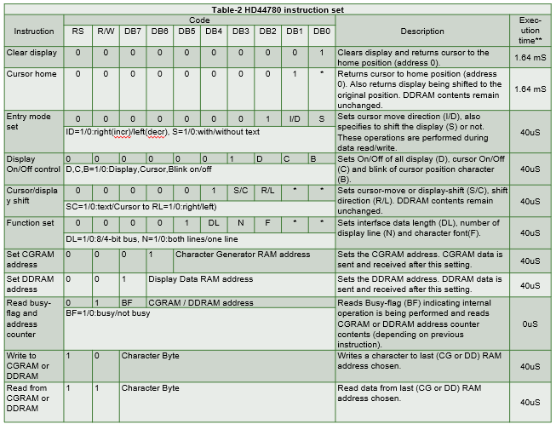

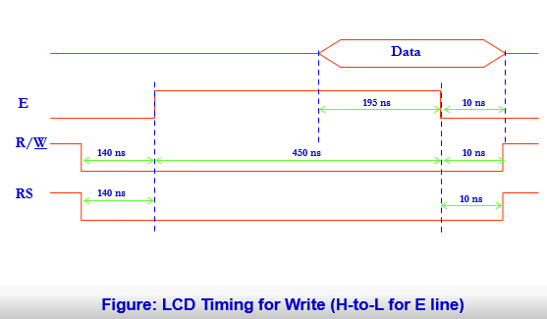

**LAB PROCEDURE**

**Exercise 1**

Create a project to interface the ATMEGA32 with LCD 8-bit data interface. Any LCD pin can be connected to port PORTC and PORTBD as shown in Figure 1. Write a C program to declare a string

“ Your Name” in the first line and the display the string “study at School of Computer Engineering”, then display in the second line this string in LCD with 16 characters at a time, delay 1 second then scroll to next 16 characters, repeat until the end of the string. Run this program in Proteus then Implement this circuit in practical AVR Experiment KIT.

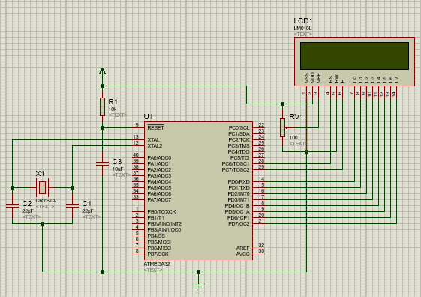

Figure 1. ATMEGA32 Interface to LCD in 8 bit mode

**Exercise 2**

Create a project to interface the ATMEGA32 with LCD 4-bit data interface. Any LCD pin can be connected to port PORTD as shown in Figure 2. Write a C program to declare a string “School of Computer Engineering International University”, then display this string in LCD with 16 characters at a time, delay 1 second then scroll to next 16 characters, repeat until the end of the string. Run this program in Proteus then Implement this circuit in practical AVR Experiment KIT.

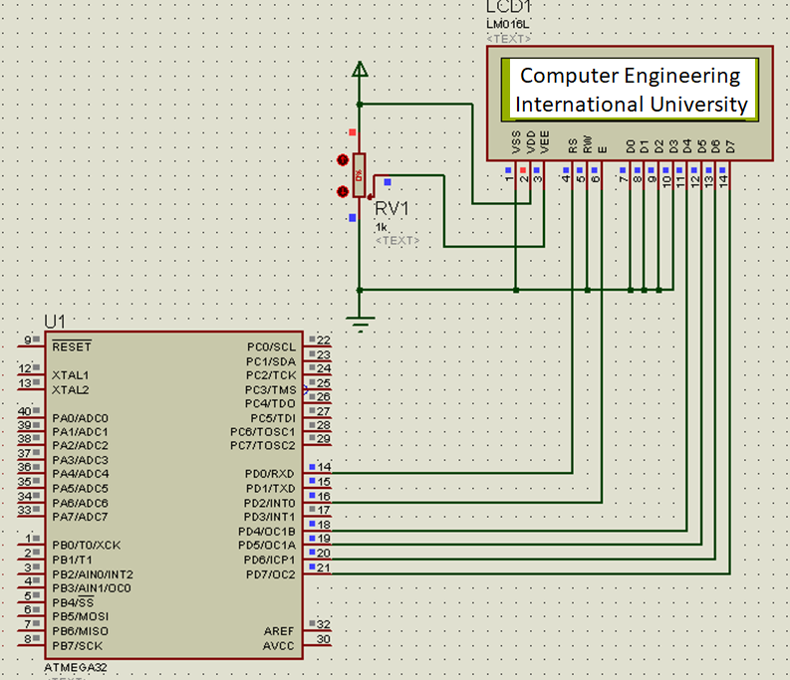

Figure 2. ATMEGA32 Interface to LCD in 4 bit mode

**Exercise 3**

Create a project to interface the ATMEGA32 with LCD 4-bit data interface. Any LCD pin can be connected to port PORTD as shown in Figure 3. Write a C program to to display the “Digital clock” string in first line and the current clock data in second line of LCD with format “hh:mm:ss’ using delay function _delay_ms() .Run this program in Proteus then Implement this circuit in practical AVR Experiment KIT.

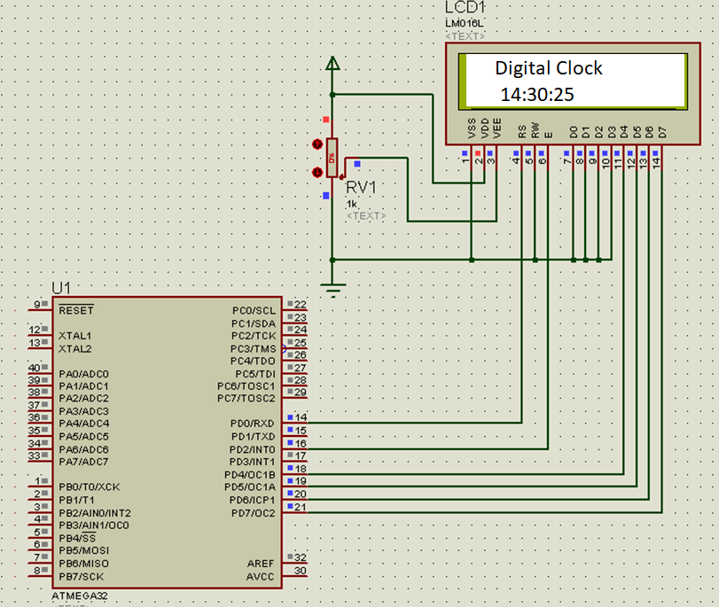

Figure 3. ATMEGA32 Interface to LCD in 4 bit mode

**Exercise 4**

Create a project to interface the ATMEGA32 with LCD 8-bit data interface. Any LCD pin can be connected to port PORTA and PORTB as shown in Figure 5. Write an AVR Assembly program to display the string “ Your Name” in first line, and the string “International University” in the second line. Run this program in Proteus and in the MPS Experiment KIT.

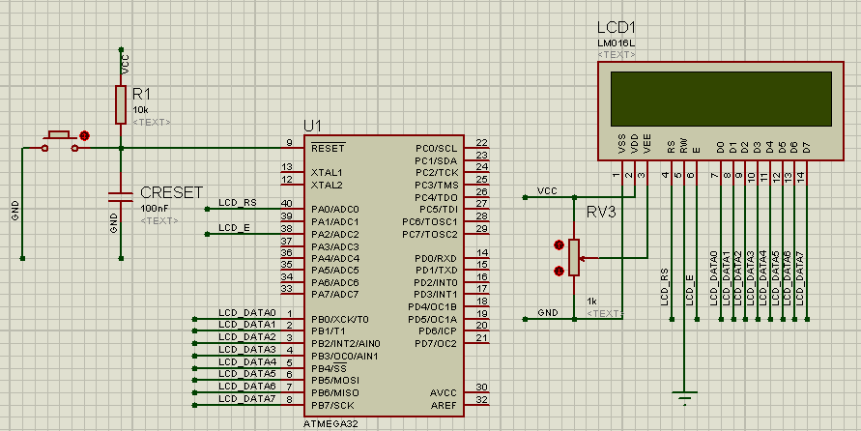

Figure 5. ATMEGA32 Interface to LCD in 8 bit mode

**Exercise 5**

Create a project to interface the ATMEGA32 with LCD 8-bit data interface. Any LCD pin can be connected to port PORTA and PORTB as shown in Figure 5. Write an AVR Assembly program to display the string “ Your Name” in first line, and the string “International University” in the second line. Run this program in Proteus and in the MPS Experiment KIT.



Figure 6. ATMEGA32 Interface to LCD in 4 bit mode

Lab 2 : Report

Draw the flow chart, Analyze the function of the code, create an AVR Studio Project to Compile this Code, Design an appropriate Schematic to simulate and test this code.

For Exercise 1 and 2 run the code in Experiment KIT, show the evidences of Practice figures.

Submit all Lab experiment evidences in the report.

**Exercise 1**

Flowchart:

+-------------------------------+

| Start Program |

+-------------------------------+

|

v

+-------------------------------+

| Initialize Ports (DDRC, DDRD)| <- Set DDRC and DDRD to output for control and data lines

+-------------------------------+

|

v

+-------------------------------+

| Initialize LCD | <- Call LCD_Initialize() to configure the LCD

+-------------------------------+

|

v

+-------------------------------+

| Display static text (Hello) | <- Display the static message "Do Minh Duy" on the LCD

+-------------------------------+

|

v

+-------------------------------+

| Start Infinite Loop | <- Loop forever to display scrolling text

+-------------------------------+

|

v

+-------------------------------+

| Call LCD_Scroll function | <- Scroll the string "study at School of Computer Engineer"

+-------------------------------+

|

v

+-------------------------------+

| Scroll the message | <- Move characters from left to right with spaces

+-------------------------------+

|

v

+-------------------------------+

| Delay and repeat | <- Delay for smooth scrolling and repeat until message finished

+-------------------------------+

|

v

+-------------------------------+

| End of Program | <- Program will keep running indefinitely

+-------------------------------+

Schematic:

+-------------------------+

| AVR Microcontroller |

| |

| PORTC (Control Pins) |-------------> RS (pin 0), RW (pin 1), E (pin 2)

| PORTD (Data Pins) |-------------> D0-D7 (pins 0-7)

| |

+-------------------------+

+-------------------------+

| 16x2 LCD Display |

| |

| RS (Register Select) |<--------------> PC0

| RW (Read/Write) |<--------------> PC1

| E (Enable) |<--------------> PC2

| D0-D7 (Data Pins) |<--------------> PD0-PD7

| VSS (Ground) |<--------------> GND

| VDD (Power) |<--------------> VCC

| V0 (Contrast) |<--------------> Potentiometer

+-------------------------+

Function:

**Analysis of the Code Functionality**

The code is designed to drive an LCD display using an AVR microcontroller. The core functionality is as follows:

1. **Hardware Setup:**
   * **PORTC** is used to control the LCD's control pins (RS, RW, and E).
   * **PORTD** is used to send the data (characters) to the LCD.
2. **LCD Commands:**
   * The LCD commands are sent via the LCD_Command() function. Each command controls the LCD's behavior (e.g., clearing the screen, setting the cursor position, turning the display on/off, etc.).
3. **Displaying Text:**
   * **LCD_Show()** is used to display individual characters on the LCD. This is used both for static text (like "Do Minh Duy") and for the scrolling text.
4. **Scrolling Text:**
   * The LCD_Scroll() function handles the scrolling text. It scrolls the string "study at School of Computer Engineer" by shifting each character to the left with spaces filled in at the right. The scrolling continues indefinitely.
5. **Delay Function:**
   * A delay() function is used throughout the program to provide timing for scrolling and pulse timing for the E pin.

#include <avr/io.h>

#include <util/delay.h>

#define RS 0 // bit 0 of Port

#define RW 1 // bit 1 of Port

#define E 2 // bit 2 of Port

#define DATA_BUS PORTD

#define DATA_DDR DDRD

#define CTRL_BUS PORTC

#define CTRL_DDR DDRC

void delay(unsigned int z) {

unsigned int x;

for(x = 0; x < z; x++)

_delay_ms(10);

}

int ready() {

delay(10);

return 1;

}

void LCD_Pulse_E(int t) {

CTRL_BUS |= 0b00000100; // E = 1;

delay(t);

CTRL_BUS &= 0b11111011; // E = 0;

delay(t);

}

int LCD_Command(unsigned char COMMAND) {

ready();

DATA_BUS = COMMAND;

CTRL_BUS = 0b11111000; // RS=0, RW=0

LCD_Pulse_E(1);

return 1;

}

int LCD_Show(unsigned char CHARACTER) {

ready();

DATA_BUS = CHARACTER;

CTRL_BUS = 0b11111001; // RS=1, RW=0

LCD_Pulse_E(1);

return 1;

}

int LCD_Initialize() {

LCD_Command(0x38); // 8 data lines, two lines, Font 5x7

LCD_Command(0x0F); // Display ON, Cursor ON, Cursor Blinking ON

LCD_Command(0x01); // Clear display and return cursor to home position

LCD_Command(0x06); // Cursor moves right

LCD_Command(0x80); // Cursor at Line 1, Position 0

return 1;

}

void LCD_Scroll(char* str) {

int len = 0;

while (str[len] != '\0') len++; // Calculate the length of the string

for (int i = 0; i <= len; i++) {

LCD_Command(0xC0); // Move cursor to Line 2

for (int j = 0; j < len; j++) {

if (j + i < len) {

LCD_Show(str[j + i]); // Display the character

} else {

LCD_Show(' '); // Fill with spaces

}

}

delay(500); // Delay for scroll speed

}

}

int main() {

DATA_DDR = 0xFF;

CTRL_DDR = 0xFF;

CTRL_BUS = 0;

DATA_BUS = 0;

LCD_Initialize();

LCD_Show('D'); // D

LCD_Show('o'); // o

LCD_Show(' '); // (space)

LCD_Show('M'); // M

LCD_Show('i'); // i

LCD_Show('n'); // n

LCD_Show('h'); // h

LCD_Show(' '); // (space)

LCD_Show('D'); // D

LCD_Show('u'); // u

LCD_Show('y'); // y

char message[] = "study at School of Computer Engineer";

for (;;) {

LCD_Scroll(message);

}

return 0;

}

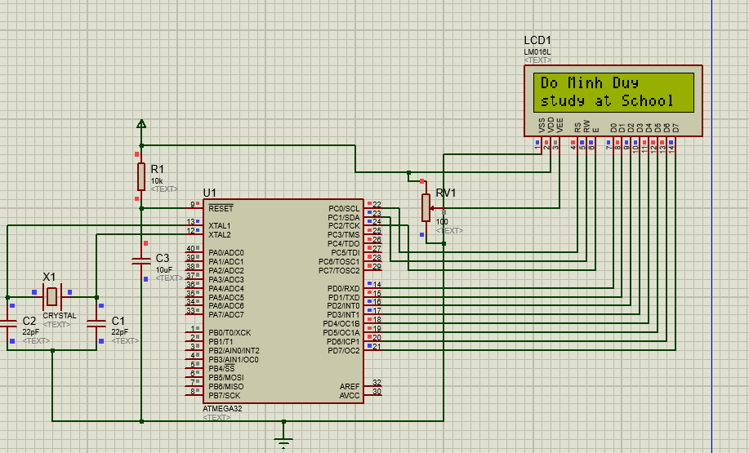

**Exercise 2**

Flowchart:

+-----------------------------------------------+

| Start Program |

+-----------------------------------------------+

|

v

+-----------------------------------------------+

| Initialize LCD and Ports (DDRx, DDRy) |

| Set up LCD pins as output |

+-----------------------------------------------+

|

v

+-----------------------------------------------+

| LCD Initialization (send command) |

| - Set LCD to 4-bit mode |

| - Set the cursor behavior and display mode|

+-----------------------------------------------+

|

v

+-----------------------------------------------+

| Main Loop: Display Message |

| - Clear LCD screen |

| - Display "Computer Engineering" |

| - Display "International University" |

| - Delay between each display cycle |

+-----------------------------------------------+

|

v

+-----------------------------------------------+

| Continue repeating the message display |

| in an infinite loop |

+-----------------------------------------------+

|

v

+-----------------------------------------------+

| End Program |

| (Infinite Loop) |

+-----------------------------------------------+

Schematic:

+-------------------------+

| AVR Microcontroller |

| |

| PORTC (Control Pins) |--------------------> RS (PC0), RW (PC1), E (PC2)

| PORTD (Data Pins) |--------------------> D0 (PD0), D1 (PD1), ..., D7 (PD7)

| |

+-------------------------+

+-------------------------+

| 16x2 LCD |

| |

| RS (Register Select) |<------------------> PC0

| RW (Read/Write) |<------------------> PC1

| E (Enable) |<------------------> PC2

| D0-D7 (Data Pins) |<------------------> PD0-PD7

| VSS (Ground) |<------------------> GND

| VDD (Power) |<------------------> VCC

| V0 (Contrast) |<------------------> Potentiometer (adjustable)

| A (Anode) |<------------------> VCC

| K (Cathode) |<------------------> GND

+-------------------------+

Function:

**1. Port Initialization**

* The program configures PORTD as the data bus and PORTC as the control bus, setting them to output mode. This is done by configuring the direction registers DATA_DDR and CTRL_DDR.

**2. LCD Initialization (LCD_init)**

* The LCD is first initialized in 4-bit mode, and several LCD commands are sent to configure the display settings:
  + 0x30: Set the LCD to 4-bit mode (sending the upper nibble first).
  + 0x20: Switch to 4-bit mode.
  + 0x28: Set 2-line mode, 5x7 character font.
  + 0x0C: Display on, cursor off.
  + 0x80: Move the cursor to the beginning of the first line.

**3. LCD Command and Data Display**

* LCD_Command() sends commands to the LCD by writing to the LCD_DATA bus and controlling the LCD_E, LCD_RS, and LCD_RW pins.
* LCD_Show() sends data (characters) to the LCD. It first sends the upper 4 bits, pulses the E pin (Enable), and then sends the lower 4 bits.
* LCD_String() iterates through a string of characters and sends each one to the LCD using LCD_Show().

**4. Main Loop**

* The main program enters an infinite loop where it:
  + Clears the display (LCD_Command(0x01)).
  + Displays the first message on the first line (LCD_Command(0x80)).
  + Displays the second message on the second line (LCD_Command(0xC0)).
  + Waits for a second before clearing the screen and starting the process again.

**5. Delays**

* The delay1s() function creates a delay of 1 second using a simple loop that calls _delay_ms(10) 100 times.

#define F_CPU 16000000UL // XTAL = 16MHZ = 8000000Hz

#include <avr/io.h>

#include <util/delay.h>

#define LCD_DATA PORTD // port connected to LCD data pins

#define DATA_DDR DDRD // direction register for data pins

#define LCD_CTRL PORTD // port connected to LCD control pins

#define CTRL_DDR DDRD // direction register for control pins

#define LCD_RS 0 // define MCU pin connected to LCD RS

#define LCD_RW 1 // define MCU pin connected to LCD R/W

#define LCD_E 2 // define MCU pin connected to LCD E

#define LCD_D0 0 // define MCU pin connected to LCD D0

#define LCD_D1 1 // define MCU pin connected to LCD D1

#define LCD_D2 2 // define MCU pin connected to LCD D1

#define LCD_D3 3 // define MCU pin connected to LCD D2

#define LCD_D4 4 // define MCU pin connected to LCD D3

#define LCD_D5 5 // define MCU pin connected to LCD D4

#define LCD_D6 6 // define MCU pin connected to LCD D5

#define LCD_D7 7 // define MCU pin connected to LCD D6

const unsigned char message1[] ="Computer Engineering ";

const unsigned char message2[] ="International University";

void LCD_Command(unsigned char cmd){ //Sends Command to LCD

//4 bit part

LCD_DATA=(cmd&0b11110000); // send upper 4-bits

LCD_CTRL|=1<<LCD_E; // E=1 ,RS=0, RW=0

_delay_ms(1); // keep E=1 for some time

LCD_CTRL&=~(1<<LCD_E); // E=0 ,RS=0, RW=0

_delay_ms(1); // keep E=0 for some time

LCD_DATA=((cmd&0b00001111)<<4); // send lover 4-bits

LCD_CTRL|=1<<LCD_E; // E=1,RS=0,RW=0

_delay_ms(1); // keep E=1 for some time

LCD_CTRL&=~(1<<LCD_E); // E=0,RS=0,RW=0

_delay_ms(1); // keep E=0 for some time

}

void delay1s(void){ //delay 1s

unsigned char i;

for(i=0;i<100;i++){

_delay_ms(10);

}

}

void LCD_Show(uint8_t ch)

{ //Sends Char to LCD

LCD_DATA=(ch&0b11110000); // send upper 4-bits

LCD_CTRL|=(1<<LCD_E)|(1<<LCD_RS); // E=1, RS=1

_delay_ms(1); // keep E=1 for some time

LCD_CTRL&=~((1<<LCD_E)); // E=0

_delay_ms(1); // keep E=0 for some time

LCD_DATA=((ch&0b00001111)<<4); // send lower 4-bits

LCD_CTRL|= (1<<LCD_E)|(1<<LCD_RS); // E=1, RS=1

_delay_ms(1); // keep E=1 for some time

LCD_CTRL&=~(1<<LCD_E); // E=0

_delay_ms(1); // keep E=0 for some time

}

void LCD_init(void){ //Initializes LCD

_delay_ms(15);

LCD_DATA=0x00; // data = 0

LCD_CTRL=0x00; // RS = RW = E = 0

DATA_DDR|=1<<LCD_D7|1<<LCD_D6|1<<LCD_D5|1<<LCD_D4;

// Set bits 4 to 7 as output pins for data out

CTRL_DDR|=1<<LCD_E|1<<LCD_RW|1<<LCD_RS;

// Set bit 0 to 2 as output pins

//---------one------ // DATA = 0x30 ;

LCD_DATA = 0<<LCD_D7|0<<LCD_D6|1<<LCD_D5|1<<LCD_D4; //4 bit mode

// E=1, RW=0, RS=0 for command mode

LCD_CTRL|= 1<<LCD_E|0<<LCD_RW|0<<LCD_RS;

_delay_ms(1); // keep E=1 for some time

// E=0;

LCD_CTRL&=~(1<<LCD_E);

_delay_ms(1); // keep E=0 for some time

//-----------two----------- // DATA = 0x30 ;

LCD_DATA=0<<LCD_D7|0<<LCD_D6|1<<LCD_D5|1<<LCD_D4;

//4 bit mode

// E=1, RW=0, RS=0 for command mode

LCD_CTRL|=1<<LCD_E|0<<LCD_RW|0<<LCD_RS;

_delay_ms(1); // keep E=1 for some time

LCD_CTRL&=~(1<<LCD_E); // E=0

_delay_ms(1); // keep E=0 for some time

//-------three-------------

// DATA = 0x20 ;

LCD_DATA=0<<LCD_D7|0<<LCD_D6|1<<LCD_D5|0<<LCD_D4; //4 bit mode

// E=1, RW=0, RS=0 for command mode

LCD_CTRL|=1<<LCD_E|0<<LCD_RW|0<<LCD_RS;

_delay_ms(1); // keep E=1 for some time

LCD_CTRL&=~(1<<LCD_E); // E=0

_delay_ms(1); // keep E=0 for some time

//--------4 bit--dual line---------------

LCD_Command(0b00101000); // 0x28

//-----increment address, invisible cursor shift------

LCD_Command(0b00001100); // 0x0C

LCD_Command(0b10000000); // 0x80

}

void LCD_String (char *str)

{

int i;

for(i=0;str[i]!=0;i++) /* send each char of string till the NULL */

{

LCD_Show(str[i]); /* call LCD data write */

}

}

int main(void){

unsigned char i;

LCD_init();//init LCD bit, dual line, cursor right

LCD_Command(0x01); //clears LCD, Cursor at Home

while(1){ //loop for ever

delay1s(); delay1s();

LCD_Command(0x80); // cursor at upper line most left

LCD_String (message1) ;

LCD_Command(0xC0); // cursor at lower line most left

LCD_String (message2);

delay1s();

delay1s();

LCD_Command(0x01); //clears LCD, Cursor at Home

}

return 0;

}

**Exercise 3**

Flowchart:

+-----------------------------------------------+

| Start Program |

+-----------------------------------------------+

|

v

+-----------------------------------------------+

| Initialize LCD and Ports (DDRx, DDRy) |

| Set up LCD pins as output |

+-----------------------------------------------+

|

v

+-----------------------------------------------+

| LCD Initialization (send command) |

| - Set LCD to 4-bit mode |

| - Set display settings (cursor, etc.) |

+-----------------------------------------------+

|

v

+-----------------------------------------------+

| Display "Digital Clock" on LCD |

| - Send the message to the top line |

+-----------------------------------------------+

|

v

+-----------------------------------------------+

| Main Loop: Update Clock |

| - Format time (hour:minute:second) |

| - Display time on second line of LCD |

| - Delay 1 second |

| - Loop back to update time again |

+-----------------------------------------------+

|

v

+-----------------------------------------------+

| End Program |

| (Infinite Loop) |

+-----------------------------------------------+

Schematic:

+-------------------------+

| AVR Microcontroller |

| |

| PORTC (Control Pins) |--------------------> RS (PC0), RW (PC1), E (PC2)

| PORTD (Data Pins) |--------------------> D0 (PD0), D1 (PD1), ..., D7 (PD7)

| |

+-------------------------+

+-------------------------+

| 16x2 LCD |

| |

| RS (Register Select) |<------------------> PC0

| RW (Read/Write) |<------------------> PC1

| E (Enable) |<------------------> PC2

| D0-D7 (Data Pins) |<------------------> PD0-PD7

| VSS (Ground) |<------------------> GND

| VDD (Power) |<------------------> VCC (5V)

| V0 (Contrast) |<------------------> Potentiometer (adjustable)

| A (Anode) |<------------------> VCC (5V)

| K (Cathode) |<------------------> GND

+-------------------------+

Function:

**Port Initialization (LCD_init):**

* The program starts by setting up the LCD's control and data pins as output.
* It then sends initialization commands to the LCD in 4-bit mode. The sequence is essential for the LCD to enter the correct mode for data display.

**Sending Commands and Data to the LCD:**

* **LCD_Command(cmd)**: This function sends a command to the LCD. It uses 4-bit data mode, first sending the upper nibble of the command, then the lower nibble. It also controls the E, RS, and RW pins to ensure correct timing and behavior of the LCD.
* **LCD_Show(ch)**: This function sends a character to the LCD in a similar way to LCD_Command, but with the RS pin set to 1, indicating that the data being sent is character data, not a command.
* **LCD_String(str)**: This function sends a string of characters to the LCD by calling LCD_Show() for each character in the string until the null terminator ('\0') is reached.

**Displaying the Time:**

* **sprintf(message2, "%0.2d:%0.2d:%0.2d", hour, minute, second)**: This formats the current time into a string in the format hh:mm:ss. The %0.2d ensures that each time component (hour, minute, second) is always two digits, padding with zeros if necessary (e.g., 08:05:03).
* The formatted time string is then displayed on the second line of the LCD using LCD_String(message2).

**Time Variables:**

* The program uses three integer variables (hour, minute, second) to keep track of the time. Currently, they are set to 16:50:00 as an initial value.

**Main Loop:**

* The program enters an infinite loop where it continuously updates and displays the time. The LCD is updated every 1 second (delay1s()).

**Delays:**

* The delay1s() function creates a 1-second delay using _delay_ms(10) in a loop that repeats 100 times. This is not precise but provides enough delay for the digital clock to be visible to the user.

#define F_CPU 16000000UL // XTAL = 16MHZ = 8000000Hz

#include <avr/io.h>

#include <util/delay.h>

#define LCD_DATA PORTD // port connected to LCD data pins

#define DATA_DDR DDRD // direction register for data pins

#define LCD_CTRL PORTD // port connected to LCD control pins

#define CTRL_DDR DDRD // direction register for control pins

#define LCD_RS 0 // define MCU pin connected to LCD RS

#define LCD_RW 1 // define MCU pin connected to LCD R/W

#define LCD_E 2 // define MCU pin connected to LCD E

#define LCD_D0 0 // define MCU pin connected to LCD D0

#define LCD_D1 1 // define MCU pin connected to LCD D1

#define LCD_D2 2 // define MCU pin connected to LCD D1

#define LCD_D3 3 // define MCU pin connected to LCD D2

#define LCD_D4 4 // define MCU pin connected to LCD D3

#define LCD_D5 5 // define MCU pin connected to LCD D4

#define LCD_D6 6 // define MCU pin connected to LCD D5

#define LCD_D7 7 // define MCU pin connected to LCD D6

const unsigned char message1[] ="Didital Clock";

const unsigned char message2[] ="00:00:00 ";

void LCD_Command(unsigned char cmd){ //Sends Command to LCD

//4 bit part

LCD_DATA=(cmd&0b11110000); // send upper 4-bits

LCD_CTRL|=1<<LCD_E; // E=1 ,RS=0, RW=0

_delay_ms(1); // keep E=1 for some time

LCD_CTRL&=~(1<<LCD_E); // E=0 ,RS=0, RW=0

_delay_ms(1); // keep E=0 for some time

LCD_DATA=((cmd&0b00001111)<<4); // send lover 4-bits

LCD_CTRL|=1<<LCD_E; // E=1,RS=0,RW=0

_delay_ms(1); // keep E=1 for some time

LCD_CTRL&=~(1<<LCD_E); // E=0,RS=0,RW=0

_delay_ms(1); // keep E=0 for some time

}

void delay1s(void){ //delay 1s

unsigned char i;

for(i=0;i<100;i++){

_delay_ms(10);

}

}

void LCD_Show(uint8_t ch)

{ //Sends Char to LCD

LCD_DATA=(ch&0b11110000); // send upper 4-bits

LCD_CTRL|=(1<<LCD_E)|(1<<LCD_RS); // E=1, RS=1

_delay_ms(1); // keep E=1 for some time

LCD_CTRL&=~((1<<LCD_E)); // E=0

_delay_ms(1); // keep E=0 for some time

LCD_DATA=((ch&0b00001111)<<4); // send lower 4-bits

LCD_CTRL|= (1<<LCD_E)|(1<<LCD_RS); // E=1, RS=1

_delay_ms(1); // keep E=1 for some time

LCD_CTRL&=~(1<<LCD_E); // E=0

_delay_ms(1); // keep E=0 for some time

}

void LCD_init(void){ //Initializes LCD

_delay_ms(15);

LCD_DATA=0x00; // data = 0

LCD_CTRL=0x00; // RS = RW = E = 0

DATA_DDR|=1<<LCD_D7|1<<LCD_D6|1<<LCD_D5|1<<LCD_D4;

// Set bits 4 to 7 as output pins for data out

CTRL_DDR|=1<<LCD_E|1<<LCD_RW|1<<LCD_RS;

// Set bit 0 to 2 as output pins

//---------one------ // DATA = 0x30 ;

LCD_DATA = 0<<LCD_D7|0<<LCD_D6|1<<LCD_D5|1<<LCD_D4; //4 bit mode

// E=1, RW=0, RS=0 for command mode

LCD_CTRL|= 1<<LCD_E|0<<LCD_RW|0<<LCD_RS;

_delay_ms(1); // keep E=1 for some time

// E=0;

LCD_CTRL&=~(1<<LCD_E);

_delay_ms(1); // keep E=0 for some time

//-----------two----------- // DATA = 0x30 ;

LCD_DATA=0<<LCD_D7|0<<LCD_D6|1<<LCD_D5|1<<LCD_D4;

//4 bit mode

// E=1, RW=0, RS=0 for command mode

LCD_CTRL|=1<<LCD_E|0<<LCD_RW|0<<LCD_RS;

_delay_ms(1); // keep E=1 for some time

LCD_CTRL&=~(1<<LCD_E); // E=0

_delay_ms(1); // keep E=0 for some time

//-------three-------------

// DATA = 0x20 ;

LCD_DATA=0<<LCD_D7|0<<LCD_D6|1<<LCD_D5|0<<LCD_D4; //4 bit mode

// E=1, RW=0, RS=0 for command mode

LCD_CTRL|=1<<LCD_E|0<<LCD_RW|0<<LCD_RS;

_delay_ms(1); // keep E=1 for some time

LCD_CTRL&=~(1<<LCD_E); // E=0

_delay_ms(1); // keep E=0 for some time

//--------4 bit--dual line---------------

LCD_Command(0b00101000); // 0x28

//-----increment address, invisible cursor shift------

LCD_Command(0b00001100); // 0x0C

LCD_Command(0b10000000); // 0x80

}

void LCD_String (char *str)

{

int i;

for(i=0;str[i]!=0;i++) /* send each char of string till the NULL */

{

LCD_Show(str[i]); /* call LCD data write */

}

}

int hour=16,minute=50,second=0;

int main(void){

unsigned char i;

LCD_init();//init LCD bit, dual line, cursor right

LCD_Command(0x01); //clears LCD, Cursor at Home

delay1s(); delay1s();

LCD_Command(0x80); // cursor at upper line most left

LCD_String (message1) ;

while(1)

{ //loop for ever

sprintf(message2, "%0.2d:%0.2d:%0.2d",hour,minute,second);

LCD_Command(0xC0); // cursor at lower line most left

LCD_String (message2);

delay1s();

delay1s();

}

return 0;

}

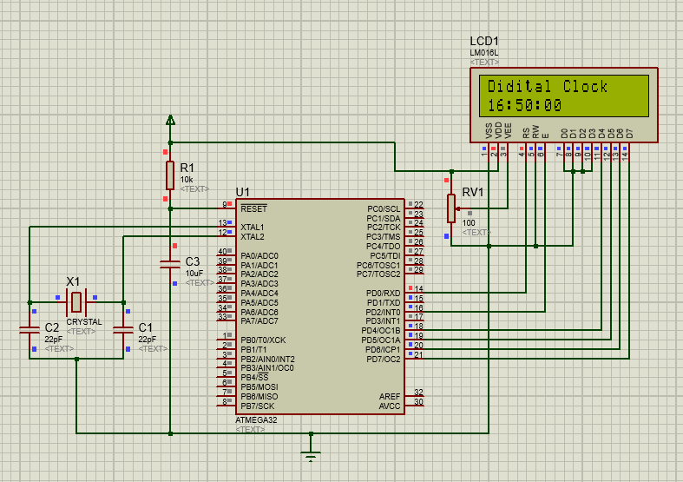

**Exercise 4**

; ***************************************************************************

; LCD-AVR-8bit.asm - Use an HD44780U based LCD with an Atmel ATmega processor

;

;

; ***************************************************************************

; File: LCD-AVR-8bit.asm

; Date: March 9, 2022

;

; Target: ATmega32

; Assembler: Atmel AvrAssembler2 (AVR Studio 6)

;

; Summary: 8-bit data interface, busy flag not implemented.

; Any LCD pin can be connected to any available I/O port.

; Includes a simple write string routine.

;

; ****************************** Program Notes ******************************

;

; This program uses an 8-bit data interface but does not use the

; busy flag to determine when the LCD controller is ready. The

; LCD RW line (pin 5) is not connected to the uP and it must be

; connected to GND for the program to function.

;

; All time delays are longer than those specified in most datasheets

; in order to accommodate slower than normal LCD modules. This

; requirement is well documented but almost always ignored. The

; information is in a note at the bottom of the right hand

; (Execution Time) column of the instruction set.

;

; ***************************************************************************

;

; The eight data lines as well as the two control lines may be

; implemented on any available I/O pin of any port. These are

; the connections used for this program:

;

; ----------- ----------

; | ATmega32 | | LCD |

; | | | |

; | PB7|---------------->|D7 |

; | PB6|---------------->|D6 |

; | PB5|---------------->|D5 |

; | PB4|---------------->|D4 |

; | PB3|---------------->|D3 |

; | PB2|---------------->|D2 |

; | PB1|---------------->|D1 |

; | PB0|---------------->|D0 |

; | | | |

; | PA1|---------------->|E |

; | | GND --->|RW |

; | PA0|---------------->|RS |

; ----------- ----------

;

; ***************************************************************************

#include "m32def.inc"

.equ fclk = 8000000 ; system clock frequency (for delays)

; register usage

.def temp = R16 ; temporary storage

; LCD interface (should agree with the diagram above)

; make sure that the LCD RW pin is connected to GND

.equ lcd_D7_port = PORTB ; lcd D7 connection

.equ lcd_D7_bit = PORTB7

.equ lcd_D7_ddr = DDRB

.equ lcd_D6_port = PORTB ; lcd D6 connection

.equ lcd_D6_bit = PORTB6

.equ lcd_D6_ddr = DDRB

.equ lcd_D5_port = PORTB ; lcd D5 connection

.equ lcd_D5_bit = PORTB5

.equ lcd_D5_ddr = DDRB

.equ lcd_D4_port = PORTB ; lcd D4 connection

.equ lcd_D4_bit = PORTB4

.equ lcd_D4_ddr = DDRB

.equ lcd_D3_port = PORTB ; lcd D3 connection

.equ lcd_D3_bit = PORTB3

.equ lcd_D3_ddr = DDRB

.equ lcd_D2_port = PORTB ; lcd D2 connection

.equ lcd_D2_bit = PORTB2

.equ lcd_D2_ddr = DDRB

.equ lcd_D1_port = PORTB ; lcd D1 connection

.equ lcd_D1_bit = PORTB1

.equ lcd_D1_ddr = DDRB

.equ lcd_D0_port = PORTB ; lcd D0 connection

.equ lcd_D0_bit = PORTB0

.equ lcd_D0_ddr = DDRB

.equ lcd_E_port = PORTA ; lcd Enable pin

.equ lcd_E_bit = PORTA2

.equ lcd_E_ddr = DDRA

.equ lcd_RS_port = PORTA ; lcd Register Select pin

.equ lcd_RS_bit = PORTA0

.equ lcd_RS_ddr = DDRA

; LCD module information

.equ lcd_LineOne = 0x00 ; start of line 1

.equ lcd_LineTwo = 0x40 ; start of line 2

;.equ lcd_LineThree = 0x14 ; start of line 3 (20x4)

;.equ lcd_lineFour = 0x54 ; start of line 4 (20x4)

;.equ lcd_LineThree = 0x10 ; start of line 3 (16x4)

;.equ lcd_lineFour = 0x50 ; start of line 4 (16x4)

; LCD instructions

.equ lcd_Clear = 0b00000001 ; replace all characters with ASCII 'space'

.equ lcd_Home = 0b00000010 ; return cursor to first position on first line

.equ lcd_EntryMode = 0b00000110 ; shift cursor from left to right on read/write

.equ lcd_DisplayOff = 0b00001000 ; turn display off

.equ lcd_DisplayOn = 0b00001100 ; display on, cursor off, don't blink character

.equ lcd_FunctionReset = 0b00110000 ; reset the LCD

.equ lcd_FunctionSet8bit = 0b00111000 ; 8-bit data, 2-line display, 5 x 7 font

.equ lcd_SetCursor = 0b10000000 ; set cursor position

; ****************************** Reset Vector *******************************

.org 0x0000

jmp start ; jump over Interrupt Vectors, Program ID etc.

;******************************* Program ID *********************************

.org 0x30

program_author:

.db "Do Minh Duy",0

program_version:

.db "International University",0,0

program_date:

.db "March,2022",0

; ****************************** Main Program Code **************************

start:

; initialize the stack pointer to the highest RAM address

ldi temp,low(RAMEND)

out SPL,temp

ldi temp,high(RAMEND)

out SPH,temp

; configure the microprocessor pins for the data lines

sbi lcd_D7_ddr, lcd_D7_bit ; 8 data lines - output

sbi lcd_D6_ddr, lcd_D6_bit

sbi lcd_D5_ddr, lcd_D5_bit

sbi lcd_D4_ddr, lcd_D4_bit

sbi lcd_D3_ddr, lcd_D3_bit

sbi lcd_D2_ddr, lcd_D2_bit

sbi lcd_D1_ddr, lcd_D1_bit

sbi lcd_D0_ddr, lcd_D0_bit

; configure the microprocessor pins for the control lines

sbi lcd_E_ddr, lcd_E_bit ; E line - output

sbi lcd_RS_ddr, lcd_RS_bit ; RS line - output

; initialize the LCD controller as determined by the equates (LCD instructions)

call lcd_init_8d ; initialize the LCD display for an 8-bit interface

; display the first line of information

ldi ZH, high(program_author) ; point to the information that is to be displayed

ldi ZL, low(program_author)

ldi temp, lcd_LineOne ; point to where the information should be displayed

call lcd_write_string_8d

; display the second line of information

ldi ZH, high(program_version) ; point to the information that is to be displayed

ldi ZL, low(program_version)

ldi temp, lcd_LineTwo ; point to where the information should be displayed

call lcd_write_string_8d

; endless loop

here:

rjmp here

; ****************************** End of Main Program Code *******************

; ============================== 8-bit LCD Subroutines ======================

; Name: lcd_init_8d

; Purpose: initialize the LCD module for a 8-bit data interface

; Entry: equates (LCD instructions) set up for the desired operation

; Exit: no parameters

; Notes: uses time delays instead of checking the busy flag

lcd_init_8d:

; Power-up delay

ldi temp, 100 ; initial 40 mSec delay

call delayTx1mS

; Reset the LCD controller.

ldi temp, lcd_FunctionReset ; first part of reset sequence

call lcd_write_instruction_8d

ldi temp, 10 ; 4.1 mS delay (min)

call delayTx1mS

ldi temp, lcd_FunctionReset ; second part of reset sequence

call lcd_write_instruction_8d

ldi temp, 200 ; 100 uS delay (min)

call delayTx1uS

ldi temp, lcd_FunctionReset ; third part of reset sequence

call lcd_write_instruction_8d

ldi temp, 200 ; this delay is omitted in the data sheet

call delayTx1uS

; Function Set instruction

ldi temp, lcd_FunctionSet8bit ; set mode, lines, and font

call lcd_write_instruction_8d

ldi temp, 80 ; 40 uS delay (min)

call delayTx1uS

; The next three instructions are specified in the data sheet as part of the initialization routine,

; so it is a good idea (but probably not necessary) to do them just as specified and then redo them

; later if the application requires a different configuration.

; Display On/Off Control instruction

ldi temp, lcd_DisplayOff ; turn display OFF

call lcd_write_instruction_8d

ldi temp, 80 ; 40 uS delay (min)

call delayTx1uS

; Clear Display instruction

ldi temp, lcd_Clear ; clear display RAM

call lcd_write_instruction_8d

ldi temp, 4 ; 1.64 mS delay (min)

call delayTx1mS

; Entry Mode Set instruction

ldi temp, lcd_EntryMode ; set desired shift characteristics

call lcd_write_instruction_8d

ldi temp, 80 ; 40 uS delay (min)

call delayTx1uS

; This is the end of the LCD controller initialization as specified in the data sheet, but the display

; has been left in the OFF condition. This is a good time to turn the display back ON.

; Display On/Off Control instruction

ldi temp, lcd_DisplayOn ; turn the display ON

call lcd_write_instruction_8d

ldi temp, 80 ; 40 uS delay (min)

call delayTx1uS

ret

; ---------------------------------------------------------------------------

; Name: lcd_write_string_8d

; Purpose: display a string of characters on the LCD

; Entry: ZH and ZL pointing to the start of the string

; (temp) contains the desired DDRAM address at which to start the display

; Exit: no parameters

; Notes: the string must end with a null (0)

; uses time delays instead of checking the busy flag

lcd_write_string_8d:

; preserve registers

push ZH ; preserve pointer registers

push ZL

; fix up the pointers for use with the 'lpm' instruction

lsl ZL ; shift the pointer one bit left for the lpm instruction

rol ZH

; set up the initial DDRAM address

ori temp, lcd_SetCursor ; convert the plain address to a set cursor instruction

call lcd_write_instruction_8d ; set up the first DDRAM address

ldi temp, 80 ; 40 uS delay (min)

call delayTx1uS

; write the string of characters

lcd_write_string_8d_01:

lpm temp, Z+ ; get a character

cpi temp, 0 ; check for end of string

breq lcd_write_string_8d_02 ; done

; arrive here if this is a valid character

call lcd_write_character_8d ; display the character

ldi temp, 80 ; 40 uS delay (min)

call delayTx1uS

rjmp lcd_write_string_8d_01 ; not done, send another character

; arrive here when all characters in the message have been sent to the LCD module

lcd_write_string_8d_02:

pop ZL ; restore pointer registers

pop ZH

ret

; ---------------------------------------------------------------------------

; Name: lcd_write_character_8d

; Purpose: send a byte of information to the LCD data register

; Entry: (temp) contains the data byte

; Exit: no parameters

; Notes: does not deal with RW (busy flag is not implemented)

lcd_write_character_8d:

sbi lcd_RS_port, lcd_RS_bit ; select the Data Register (RS high)

cbi lcd_E_port, lcd_E_bit ; make sure E is initially low

call lcd_write_8 ; write the data

ret

; ---------------------------------------------------------------------------

; Name: lcd_write_instruction_8d

; Purpose: send a byte of information to the LCD instruction register

; Entry: (temp) contains the data byte

; Exit: no parameters

; Notes: does not deal with RW (busy flag is not implemented)

lcd_write_instruction_8d:

cbi lcd_RS_port, lcd_RS_bit ; select the Instruction Register (RS low)

cbi lcd_E_port, lcd_E_bit ; make sure E is initially low

call lcd_write_8 ; write the instruction

ret

; ---------------------------------------------------------------------------

; Name: lcd_write_8

; Purpose: send a byte of information to the LCD module

; Entry: (temp) contains the data byte

; RS is configured for the desired LCD register

; E is low

; RW is low

; Exit: no parameters

; Notes: use either time delays or the busy flag

lcd_write_8:

; set up the data bits

sbi lcd_D7_port, lcd_D7_bit ; assume that the data bit is '1'

sbrs temp, 7 ; check the actual data value

cbi lcd_D7_port, lcd_D7_bit ; arrive here only if the data was actually '0'

sbi lcd_D6_port, lcd_D6_bit ; repeat for each data bit

sbrs temp, 6

cbi lcd_D6_port, lcd_D6_bit

sbi lcd_D5_port, lcd_D5_bit

sbrs temp, 5

cbi lcd_D5_port, lcd_D5_bit

sbi lcd_D4_port, lcd_D4_bit

sbrs temp, 4

cbi lcd_D4_port, lcd_D4_bit

sbi lcd_D3_port, lcd_D3_bit

sbrs temp, 3

cbi lcd_D3_port, lcd_D3_bit

sbi lcd_D2_port, lcd_D2_bit

sbrs temp, 2

cbi lcd_D2_port, lcd_D2_bit

sbi lcd_D1_port, lcd_D1_bit

sbrs temp, 1

cbi lcd_D1_port, lcd_D1_bit

sbi lcd_D0_port, lcd_D0_bit

sbrs temp, 0

cbi lcd_D0_port, lcd_D0_bit

; write the data

; 'Address set-up time' (40 nS)

sbi lcd_E_port, lcd_E_bit ; Enable pin high

call delay1uS ; implement 'Data set-up time' (80 nS) and 'Enable pulse width' (230 nS)

cbi lcd_E_port, lcd_E_bit ; Enable pin low

call delay1uS ; implement 'Data hold time' (10 nS) and 'Enable cycle time' (500 nS)

ret

; ============================== End of 8-bit LCD Subroutines ===============

; ============================== Time Delay Subroutines =====================

; Name: delayYx1mS

; Purpose: provide a delay of (YH:YL) x 1 mS

; Entry: (YH:YL) = delay data

; Exit: no parameters

; Notes: the 16-bit register provides for a delay of up to 65.535 Seconds

; requires delay1mS

delayYx1mS:

call delay1mS ; delay for 1 mS

dec YL ; update the the delay counter

brne delayYx1mS ; counter is not zero

; arrive here when delay counter is zero (total delay period is finished)

ret

; ---------------------------------------------------------------------------

; Name: delayTx1mS

; Purpose: provide a delay of (temp) x 1 mS

; Entry: (temp) = delay data

; Exit: no parameters

; Notes: the 8-bit register provides for a delay of up to 255 mS

; requires delay1mS

delayTx1mS:

call delay1mS ; delay for 1 mS

dec temp ; update the delay counter

brne delayTx1mS ; counter is not zero

; arrive here when delay counter is zero (total delay period is finished)

ret

; ---------------------------------------------------------------------------

; Name: delay1mS

; Purpose: provide a delay of 1 mS

; Entry: no parameters

; Exit: no parameters

; Notes: chews up fclk/1000 clock cycles (including the 'call')

delay1mS:

push YL ; [2] preserve registers

push YH ; [2]

ldi YL, low (((fclk/1000)-18)/4) ; [1] delay counter

ldi YH, high(((fclk/1000)-18)/4) ; [1]

delay1mS_01:

dec YL ; [2] update the the delay counter

brne delay1mS_01 ; [2] delay counter is not zero

; arrive here when delay counter is zero

pop YH ; [2] restore registers

pop YL ; [2]

ret ; [4]

; ---------------------------------------------------------------------------

; Name: delayTx1uS

; Purpose: provide a delay of (temp) x 1 uS with a 16 MHz clock frequency

; Entry: (temp) = delay data

; Exit: no parameters

; Notes: the 8-bit register provides for a delay of up to 255 uS

; requires delay1uS

delayTx1uS:

call delay1uS ; delay for 1 uS

dec temp ; decrement the delay counter

brne delayTx1uS ; counter is not zero

; arrive here when delay counter is zero (total delay period is finished)

ret

; ---------------------------------------------------------------------------

; Name: delay1uS

; Purpose: provide a delay of 1 uS with a 16 MHz clock frequency

; Entry: no parameters

; Exit: no parameters

; Notes: add another push/pop for 20 MHz clock frequency

delay1uS:

push temp ; [2] these instructions do nothing except consume clock cycles

pop temp ; [2]

push temp ; [2]

pop temp ; [2]

ret ; [4]

; ============================== End of Time Delay Subroutines ==============

Flowchart:

[Start]

|

V

[Initialize Stack Pointer]

|

V

[Set Up I/O Pins for LCD]

|

V

[Call lcd_init_8d] ---> [LCD Initialized?] --- Yes --> [Continue]

|

V

[Display First Line of Info]

|

V

[Display Second Line of Info]

|

V

[Endless Loop (Wait)]

|

V

[End]

Schematic:

+-----------------+

| |

+--------| ATmega32 |

| | |

| | PB0 (D0) ----|-----> D0 (LCD)

| | PB1 (D1) ----|-----> D1 (LCD)

| | PB2 (D2) ----|-----> D2 (LCD)

| | PB3 (D3) ----|-----> D3 (LCD)

| | PB4 (D4) ----|-----> D4 (LCD)

| | PB5 (D5) ----|-----> D5 (LCD)

| | PB6 (D6) ----|-----> D6 (LCD)

| | PB7 (D7) ----|-----> D7 (LCD)

| | PA0 (RS) ----|-----> RS (LCD)

| | PA1 (E) ----|-----> E (LCD)

| | GND ----|-----> RW (LCD) (connected to GND)

| | |

| | |

| +-----------------+

|

| +--------------+

| | |

+----------| HD44780U |

| LCD |

| |

| |

| |

+--------------+

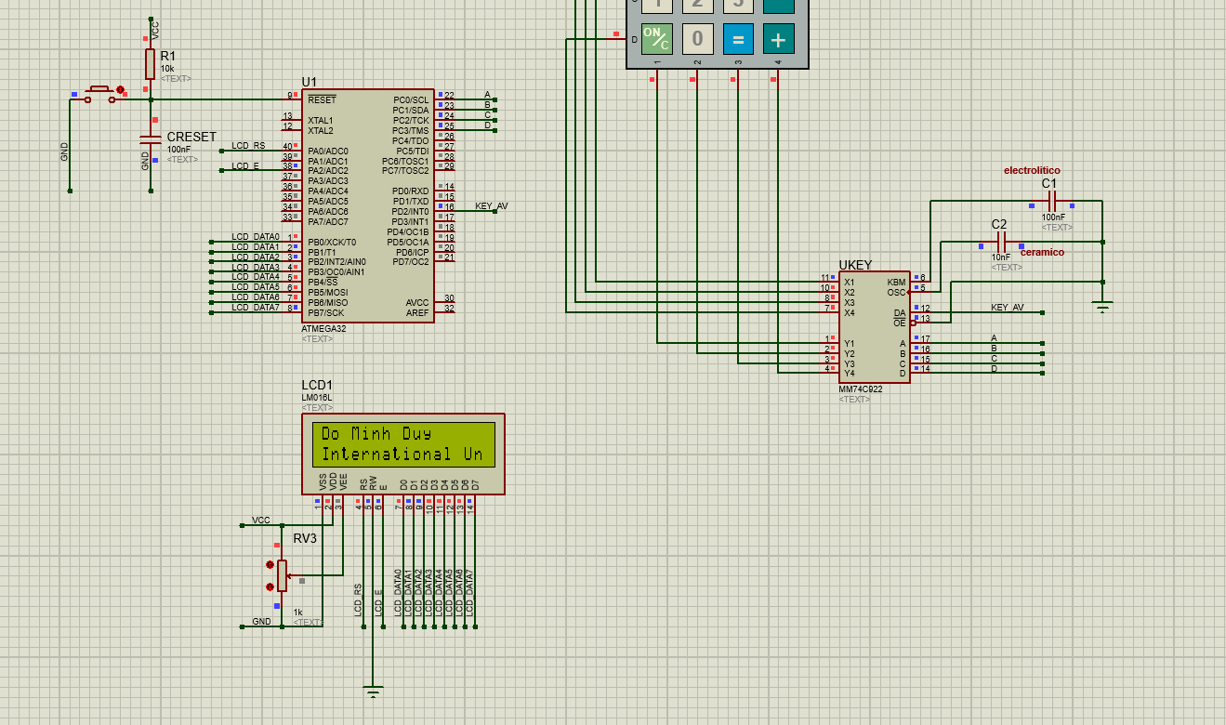

**Exercise 5**

; ***************************************************************************

; LCD-AVR-8bit.asm - Use an HD44780U based LCD with an Atmel ATmega processor

;

;

; ***************************************************************************

; File: LCD-AVR-8bit.asm

; Date: March 9, 2022

;

; Target: ATmega32

; Assembler: Atmel AvrAssembler2 (AVR Studio 6)

;

; Summary: 8-bit data interface, busy flag not implemented.

; Any LCD pin can be connected to any available I/O port.

; Includes a simple write string routine.

;

; ****************************** Program Notes ******************************

;

; This program uses an 8-bit data interface but does not use the

; busy flag to determine when the LCD controller is ready. The

; LCD RW line (pin 5) is not connected to the uP and it must be

; connected to GND for the program to function.

;

; All time delays are longer than those specified in most datasheets

; in order to accommodate slower than normal LCD modules. This

; requirement is well documented but almost always ignored. The

; information is in a note at the bottom of the right hand

; (Execution Time) column of the instruction set.

;

; ***************************************************************************

;

; The eight data lines as well as the two control lines may be

; implemented on any available I/O pin of any port. These are

; the connections used for this program:

;

; ----------- ----------

; | ATmega32 | | LCD |

; | | | |

; | PB7|---------------->|D7 |

; | PB6|---------------->|D6 |

; | PB5|---------------->|D5 |

; | PB4|---------------->|D4 |

; | PB3|---------------->|D3 |

; | PB2|---------------->|D2 |

; | PB1|---------------->|D1 |

; | PB0|---------------->|D0 |

; | | | |

; | PA1|---------------->|E |

; | | GND --->|RW |

; | PA0|---------------->|RS |

; ----------- ----------

;

; ***************************************************************************

#include "m32def.inc"

.equ fclk = 8000000 ; system clock frequency (for delays)

; register usage

.def temp = R16 ; temporary storage

; LCD interface (should agree with the diagram above)

; make sure that the LCD RW pin is connected to GND

.equ lcd_D7_port = PORTD ; lcd D7 connection

.equ lcd_D7_bit = PORTD7

.equ lcd_D7_ddr = DDRD

.equ lcd_D6_port = PORTD ; lcd D6 connection

.equ lcd_D6_bit = PORTD6

.equ lcd_D6_ddr = DDRD

.equ lcd_D5_port = PORTD ; lcd D5 connection

.equ lcd_D5_bit = PORTD5

.equ lcd_D5_ddr = DDRD

.equ lcd_D4_port = PORTD ; lcd D4 connection

.equ lcd_D4_bit = PORTD4

.equ lcd_D4_ddr = DDRD

.equ lcd_E_port = PORTD ; lcd Enable pin

.equ lcd_E_bit = PORTD2

.equ lcd_E_ddr = DDRD

.equ lcd_RS_port = PORTD ; lcd Register Select pin

.equ lcd_RS_bit = PORTD0

.equ lcd_RS_ddr = DDRD

; LCD module information

.equ lcd_LineOne = 0x00 ; start of line 1

.equ lcd_LineTwo = 0x40 ; start of line 2

;.equ lcd_LineThree = 0x14 ; start of line 3 (20x4)

;.equ lcd_lineFour = 0x54 ; start of line 4 (20x4)

;.equ lcd_LineThree = 0x10 ; start of line 3 (16x4)

;.equ lcd_lineFour = 0x50 ; start of line 4 (16x4)

; LCD instructions

.equ lcd_Clear = 0b00000001 ; replace all characters with ASCII 'space'

.equ lcd_Home = 0b00000010 ; return cursor to first position on first line

.equ lcd_EntryMode = 0b00000110 ; shift cursor from left to right on read/write

.equ lcd_DisplayOff = 0b00001000 ; turn display off

.equ lcd_DisplayOn = 0b00001100 ; display on, cursor off, don't blink character

.equ lcd_FunctionReset = 0b00110000 ; reset the LCD

.equ lcd_FunctionSet4bit = 0x02 ; 8-bit data, 2-line display, 5 x 7 font

.equ lcd_CMD_4BIT_MODE = 0x28 ; = 0x30 ; 4-bit data, 2 lines, 5x7 matrix

.equ lcd_SetCursor = 0b10000000 ; set cursor position

; ****************************** Reset Vector *******************************

.org 0x0000

jmp start ; jump over Interrupt Vectors, Program ID etc.

;******************************* Program ID *********************************

.org 0x30

program_author:

.db "Do Minh Duy",0

program_version:

.db "International University",0,0

program_date:

.db "March,2022",0

; ****************************** Main Program Code **************************

start:

; initialize the stack pointer to the highest RAM address

ldi temp,low(RAMEND)

out SPL,temp

ldi temp,high(RAMEND)

out SPH,temp

; configure the microprocessor pins for the data lines

LDI R16,0xFF

OUT DDRD,R16

; configure the microprocessor pins for the control lines

sbi lcd_E_ddr, lcd_E_bit ; E line - output

sbi lcd_RS_ddr, lcd_RS_bit ; RS line - output

; initialize the LCD controller as determined by the equates (LCD instructions)

call lcd_init_8d ; initialize the LCD display for an 8-bit interface

; display the first line of information

ldi ZH, high(program_author) ; point to the information that is to be displayed

ldi ZL, low(program_author)

ldi temp, lcd_LineOne ; point to where the information should be displayed

call lcd_write_string_8d

; display the second line of information

ldi ZH, high(program_version) ; point to the information that is to be displayed

ldi ZL, low(program_version)

ldi temp, lcd_LineTwo ; point to where the information should be displayed

call lcd_write_string_8d

; endless loop

here:

rjmp here

; ****************************** End of Main Program Code *******************

; ============================== 8-bit LCD Subroutines ======================

; Name: lcd_init_8d

; Purpose: initialize the LCD module for a 8-bit data interface

; Entry: equates (LCD instructions) set up for the desired operation

; Exit: no parameters

; Notes: uses time delays instead of checking the busy flag

lcd_init_8d:

; Power-up delay

ldi temp, 100 ; initial 40 mSec delay

call delayTx1mS

; Reset the LCD controller.

ldi temp, lcd_FunctionReset ; first part of reset sequence

call lcd_write_instruction_8d

ldi temp, 10 ; 4.1 mS delay (min)

call delayTx1mS

ldi temp, lcd_FunctionReset ; second part of reset sequence

call lcd_write_instruction_8d

ldi temp, 200 ; 100 uS delay (min)

call delayTx1uS

ldi temp, lcd_FunctionReset ; third part of reset sequence

call lcd_write_instruction_8d

ldi temp, 200 ; this delay is omitted in the data sheet

call delayTx1uS

; Function Set instruction

ldi temp, lcd_FunctionSet4bit ; set mode 4 bit, lines, and font

call lcd_write_instruction_8d

ldi temp, 80 ; 40 uS delay (min)

call delayTx1uS

; Function Set instruction

ldi temp, lcd_CMD_4BIT_MODE ; set mode 4 bit, lines, and font

call lcd_write_instruction_8d

ldi temp, 80 ; 40 uS delay (min)

call delayTx1uS

; The next three instructions are specified in the data sheet as part of the initialization routine,

; so it is a good idea (but probably not necessary) to do them just as specified and then redo them

; later if the application requires a different configuration.

; Display On/Off Control instruction

ldi temp, lcd_DisplayOff ; turn display OFF

call lcd_write_instruction_8d

ldi temp, 80 ; 40 uS delay (min)

call delayTx1uS

; Clear Display instruction

ldi temp, lcd_Clear ; clear display RAM

call lcd_write_instruction_8d

ldi temp, 4 ; 1.64 mS delay (min)

call delayTx1mS

; Entry Mode Set instruction

ldi temp, lcd_EntryMode ; set desired shift characteristics

call lcd_write_instruction_8d

ldi temp, 80 ; 40 uS delay (min)

call delayTx1uS

; This is the end of the LCD controller initialization as specified in the data sheet, but the display

; has been left in the OFF condition. This is a good time to turn the display back ON.

; Display On/Off Control instruction

ldi temp, lcd_DisplayOn ; turn the display ON

call lcd_write_instruction_8d

ldi temp, 80 ; 40 uS delay (min)

call delayTx1uS

ret

; ---------------------------------------------------------------------------

; Name: lcd_write_string_8d

; Purpose: display a string of characters on the LCD

; Entry: ZH and ZL pointing to the start of the string

; (temp) contains the desired DDRAM address at which to start the display

; Exit: no parameters

; Notes: the string must end with a null (0)

; uses time delays instead of checking the busy flag

lcd_write_string_8d:

; preserve registers

push ZH ; preserve pointer registers

push ZL

; fix up the pointers for use with the 'lpm' instruction

lsl ZL ; shift the pointer one bit left for the lpm instruction

rol ZH

; set up the initial DDRAM address

ori temp, lcd_SetCursor ; convert the plain address to a set cursor instruction

call lcd_write_instruction_8d ; set up the first DDRAM address

ldi temp, 80 ; 40 uS delay (min)

call delayTx1uS

; write the string of characters

lcd_write_string_8d_01:

lpm temp, Z+ ; get a character

cpi temp, 0 ; check for end of string

breq lcd_write_string_8d_02 ; done

; arrive here if this is a valid character

call lcd_write_character_8d ; display the character

ldi temp, 80 ; 40 uS delay (min)

call delayTx1uS

rjmp lcd_write_string_8d_01 ; not done, send another character

; arrive here when all characters in the message have been sent to the LCD module

lcd_write_string_8d_02:

pop ZL ; restore pointer registers

pop ZH

ret

; ---------------------------------------------------------------------------

; Name: lcd_write_character_8d

; Purpose: send a byte of information to the LCD data register

; Entry: (temp) contains the data byte

; Exit: no parameters

; Notes: does not deal with RW (busy flag is not implemented)

lcd_write_character_8d:

sbi lcd_RS_port, lcd_RS_bit ; select the Data Register (RS high)

cbi lcd_E_port, lcd_E_bit ; make sure E is initially low

call LCD_4bit_write_Data ; write the data

ret

; ---------------------------------------------------------------------------

; Name: lcd_write_instruction_8d

; Purpose: send a byte of information to the LCD instruction register

; Entry: (temp) contains the data byte

; Exit: no parameters

; Notes: does not deal with RW (busy flag is not implemented)

lcd_write_instruction_8d:

cbi lcd_RS_port, lcd_RS_bit ; select the Instruction Register (RS low)

cbi lcd_E_port, lcd_E_bit ; make sure E is initially low

call LCD_4bit_write_Data ; write the instruction

ret

; ---------------------------------------------------------------------------

; Name: lcd_write_8

; Purpose: send a byte of information to the LCD module

; Entry: (temp) contains the data byte

; RS is configured for the desired LCD register

; E is low

; RW is low

; Exit: no parameters

; Notes: use either time delays or the busy flag

LCD_4bit_write_Data:

; Send upper nibble

ldi r20, 0xF0 ; Mask for upper nibble

and r20, temp

sbi lcd_D7_port, lcd_D7_bit ; assume that the data bit is '1'

sbrs r20, 7 ; check the actual data value

cbi lcd_D7_port, lcd_D7_bit ; arrive here only if the data was actually '0'

sbi lcd_D6_port, lcd_D6_bit ; repeat for each data bit

sbrs r20, 6

cbi lcd_D6_port, lcd_D6_bit

sbi lcd_D5_port, lcd_D5_bit

sbrs r20, 5

cbi lcd_D5_port, lcd_D5_bit

sbi lcd_D4_port, lcd_D4_bit

sbrs r20, 4

cbi lcd_D4_port, lcd_D4_bit

; write the data

; 'Address set-up time' (40 nS)

sbi lcd_E_port, lcd_E_bit ; Enable pin high

call delay1uS ; implement 'Data set-up time' (80 nS) and 'Enable pulse width' (230 nS)

cbi lcd_E_port, lcd_E_bit ; Enable pin low

call delay1uS ; implement 'Data hold time' (10 nS) and 'Enable cycle time' (500 n

nop

; Send lower nibble

ldi r20, 0x0F ; Mask for lower nibble

and r20, temp

LSL R20

LSL R20

LSL R20

LSL R20

sbi lcd_D7_port, lcd_D7_bit ; assume that the data bit is '1'

sbrs r20, 7 ; check the actual data value

cbi lcd_D7_port, lcd_D7_bit ; arrive here only if the data was actually '0'

sbi lcd_D6_port, lcd_D6_bit ; repeat for each data bit

sbrs r20, 6

cbi lcd_D6_port, lcd_D6_bit

sbi lcd_D5_port, lcd_D5_bit

sbrs r20, 5

cbi lcd_D5_port, lcd_D5_bit

sbi lcd_D4_port, lcd_D4_bit

sbrs r20, 4

cbi lcd_D4_port, lcd_D4_bit

; write the data

; 'Address set-up time' (40 nS)

sbi lcd_E_port, lcd_E_bit ; Enable pin high

call delay1uS ; implement 'Data set-up time' (80 nS) and 'Enable pulse width' (230 nS)

cbi lcd_E_port, lcd_E_bit ; Enable pin low

call delay1uS ; implement 'Data hold time' (10 nS) and 'Enable cycle time' (500 n

nop

nop

ret

; ============================== End of 8-bit LCD Subroutines ===============

; ============================== Time Delay Subroutines =====================

; Name: delayYx1mS

; Purpose: provide a delay of (YH:YL) x 1 mS

; Entry: (YH:YL) = delay data

; Exit: no parameters

; Notes: the 16-bit register provides for a delay of up to 65.535 Seconds

; requires delay1mS

delayYx1mS:

call delay1mS ; delay for 1 mS

dec YL ; update the the delay counter

brne delayYx1mS ; counter is not zero

; arrive here when delay counter is zero (total delay period is finished)

ret

; ---------------------------------------------------------------------------

; Name: delayTx1mS

; Purpose: provide a delay of (temp) x 1 mS

; Entry: (temp) = delay data

; Exit: no parameters

; Notes: the 8-bit register provides for a delay of up to 255 mS

; requires delay1mS

delayTx1mS:

call delay1mS ; delay for 1 mS

dec temp ; update the delay counter

brne delayTx1mS ; counter is not zero

; arrive here when delay counter is zero (total delay period is finished)

ret

; ---------------------------------------------------------------------------

; Name: delay1mS

; Purpose: provide a delay of 1 mS

; Entry: no parameters

; Exit: no parameters

; Notes: chews up fclk/1000 clock cycles (including the 'call')

delay1mS:

push YL ; [2] preserve registers

push YH ; [2]

ldi YL, low (((fclk/1000)-18)/4) ; [1] delay counter

ldi YH, high(((fclk/1000)-18)/4) ; [1]

delay1mS_01:

dec YL ; [2] update the the delay counter

brne delay1mS_01 ; [2] delay counter is not zero

; arrive here when delay counter is zero

pop YH ; [2] restore registers

pop YL ; [2]

ret ; [4]

; ---------------------------------------------------------------------------

; Name: delayTx1uS

; Purpose: provide a delay of (temp) x 1 uS with a 16 MHz clock frequency

; Entry: (temp) = delay data

; Exit: no parameters

; Notes: the 8-bit register provides for a delay of up to 255 uS

; requires delay1uS

delayTx1uS:

call delay1uS ; delay for 1 uS

dec temp ; decrement the delay counter

brne delayTx1uS ; counter is not zero

; arrive here when delay counter is zero (total delay period is finished)

ret

; ---------------------------------------------------------------------------

; Name: delay1uS

; Purpose: provide a delay of 1 uS with a 16 MHz clock frequency

; Entry: no parameters

; Exit: no parameters

; Notes: add another push/pop for 20 MHz clock frequency

delay1uS:

push temp ; [2] these instructions do nothing except consume clock cycles

pop temp ; [2]

push temp ; [2]

pop temp ; [2]

ret ; [4]

; ============================== End of Time Delay Subroutines ==============

Schematic:

+--------------------+ +------------------+

| | | |

| ATmega32 | | HD44780U LCD |

| | | |

| +------------+ | | +----------+ |

| | | | | | | |

| | PORTD |---|-> D0-D7 | | D0-D7 | |

| | (PB0-PB7)| | | | | |

| | | | | | | |

| | PA0(RS) |---|-> RS | | RS | |

| | PA1(E) |---|-> E | | E | |

| | GND |---|-> RW | | RW (GND) | |

| +------------+ | | +----------+ |

+--------------------+ +------------------+

Flowchart:

+--------------------------+

| Start |

+--------------------------+

|

+--------------------------+

| Initialize Stack Pointer |

+--------------------------+

|

+--------------------------+

| Configure Data Lines |

| (PORTD as output) |

+--------------------------+

|

+--------------------------+

| Configure Control Lines |

| (RS, E as output) |

+--------------------------+

|

+--------------------------+

| LCD Initialization |

| (Send reset commands) |

+--------------------------+

|

+--------------------------+

| Display First Line (Name) |

+--------------------------+

|

+--------------------------+

| Display Second Line |

| (University Name) |

+--------------------------+

|

+--------------------------+

| Endless Loop (here) |

+--------------------------+

|

+--------------------------+

| Subroutines |

| (lcd_write_string_8d, |

| lcd_write_instruction_8d, |

| lcd_write_character_8d) |

+--------------------------+

**END**